ASSESSMENT TOOL-2
CONCEPT MAPPING
NAME:N.AKSHAYA
REG.NO:192425129
COURSE CODE:ITA0509
COURSE NAME:COMPUTER VISION

- Construct a comprehensive and well-organized concept map that accurately identifies all key concepts from literature involved in the pipeline from real-world scene capture to digital image representation, establishes clear and meaningful relationships among intermediate transformations and dependencies, integrates insights from multiple studies, and presents the information in a clear and visually structured manner.
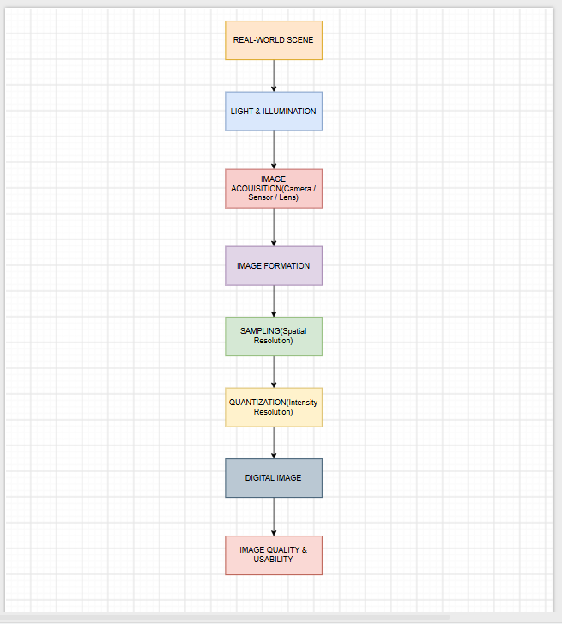
- Develop a hierarchically structured concept map that identifies major stages of visual data handling in a Computer Vision system, clearly illustrates logical relationships and contributions of each stage toward generating meaningful outputs, incorporates relevant literature connections, and ensures clarity and readability.

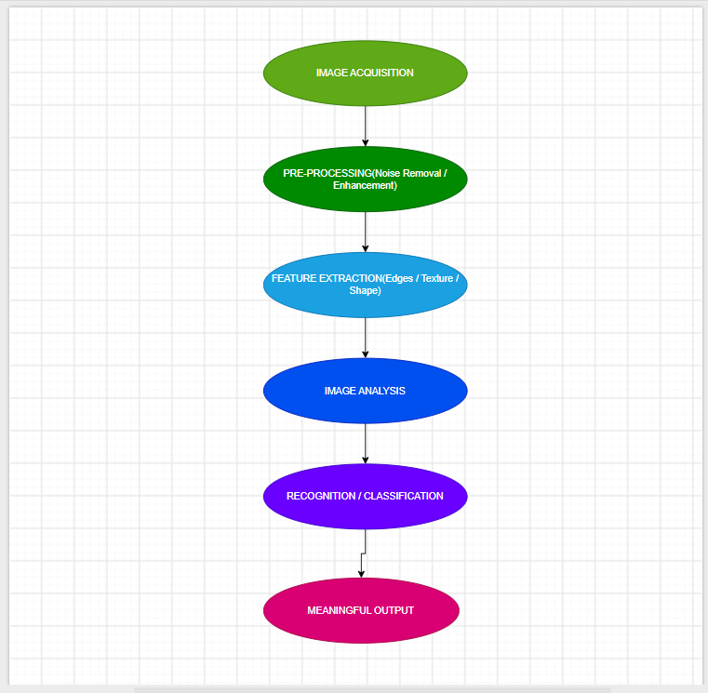

- Create a detailed concept map that accurately identifies concepts related to image resolution and intensity levels, establishes clear cause–effect relationships with image quality and usability, integrates supporting evidence from literature, and presents the concepts in a logically organized and visually clear format.

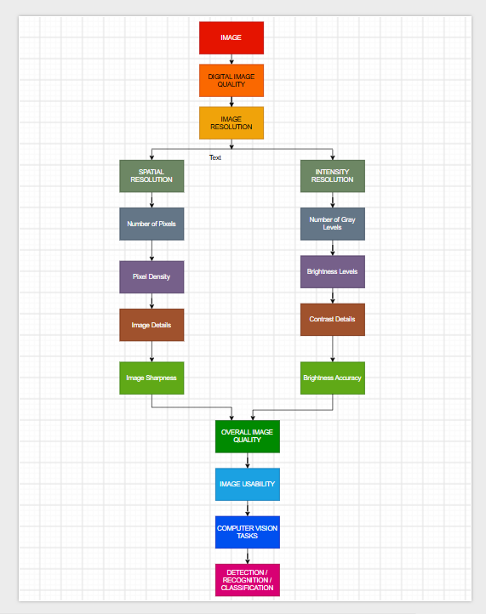

- Design an analytically organized concept map that identifies key factors in image acquisition conditions, clearly links them to downstream processing and application performance through meaningful relationships, integrates findings from relevant studies, and ensures a well-structured and easy-to-interpret presentation.

